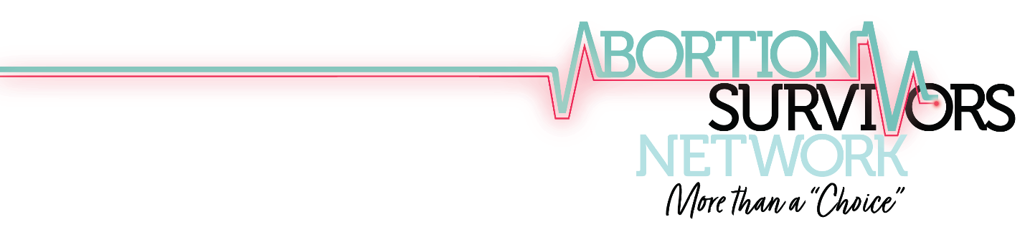

Demonstrated Need for Specialized Support for Abortion Survivors and Families: An Overview of the Literature on Trauma In The Womb and Its Lifetime of Effects:

Our society has failed to serve and understand abortion survivors for decades.

There are countless obstacles to healing and support. Family secrets lock abortion survivors and their biological and adoptive families in shame and silence. Biological mothers who experience a failed abortion, along with their babies, are culturally marginalized. These challenges, and others, prevent the individual and the family unit from receiving the healing designed for their unique strengths and needs. Community support is vital for survivors to break through challenges with rejection, trust, boundaries, healthy relationships, and more.

Where do these issues and issues like chronic insomnia, fibromyalgia, chronic fatigue, crippling anxiety, depression, suicidal ideations, low self-esteem, and self-worth originate? Study after study shows that stress-induced in utero reveals itself later in life in various forms, presenting different unique mental, emotional, and even physical health challenges. The stress that abortion survivors experience in utero, including both their biological mother’s stress in an unplanned or crisis pregnancy, facing an abortion decision, coupled with the incredible pressure of being subjected to an abortion procedure, creates a toxic level of stress which has a lifelong impact that is unimaginable to most.

Abortion survivors often need help to overcome significant mental, emotional, social, and physical disorders and traumas. These issues impact them and strain healthcare and mental health resources who can’t get to the root of the problem. How can they, when they approach the subject with underlying beliefs and understandings like “this never happens,” or “why can’t you just be happy that you survived?” This approach only affirms the sentiments of isolation, shame, and experiencing debilitating emotional and physical pain that many survivors have endured for decades.

Despite statistics that the abortion rate is declining year after year in the United States, babies continue to receive death sentences before they even have a chance to live outside the womb and take their first breath. There is no guarantee that babies born after a failed abortion will receive medical care. This issue is significant enough that Congress has repeatedly introduced legislation to ensure that this does not happen, and legislation ensuring that babies born alive are guaranteed medical care is pending in the House of Representatives. Further, policymakers realize that there is missing information in the debate over abortion, and those who are aborted—states are not required to collect and report data on failed abortion. This valuable piece of information, which at this time is frequently discovered by the victims of abortion unintentionally- is vital to understanding the true impact of abortion on families, communities, and our society.

After birth, survivors present unique health and emotional needs that the Abortion Survivors Network specializes in addressing. As a starting point, consider this research about how the emotions of mothers’ impact babies in utero:
“There is now considerable evidence that the mother’s emotional state during pregnancy can affect the development of her baby’s brain.
This is because of “fetal programming,” where a changing environment in the womb through different sensitive periods can alter the development of the fetus. This then goes on to affect the child in the longer term and into adulthood.

This is important in physical health; if a baby grows less well than it should in the womb, it will be at greater risk of coronary heart disease or diabetes in later life. But there is now considerable evidence that fetal programming is also crucial for neurodevelopment in the brain.

Prenatal stress has been associated with the risk of a wide range of outcomes. These include both neurodevelopmental and physical problems, with the likes of anxiety, ADHD and lower cognitive development on one hand and diseases such as asthma on the other.”

It’s not hard to imagine the range of emotions many abortion survivors’ biological mothers went through during their pregnancies. Whether they were angry or fearful, or someone else led them to be anxious and depressed because of that, the reality is that survivors’ biological mothers experienced high levels of stress and emotions, which were passed along to their babies. Add to that the emotions of undergoing abortion attempts, and there’s a recipe for later disastrous emotions and struggles—inexplicable anxiety, nagging depression, feelings of worthlessness, rejection, psychosomatic complaints, even seemingly mysterious, chronic health issues.

Whether it a biological mother or someone around her who influenced her, abortion survivors experience rejection at a formative time in development. And although survivors bear no memory of it, they have a cellular memory of it in their bodies. This research is particularly compelling.

Although the experience of surviving an abortion is unique, survivors have many shared experiences with other trauma victims like sexual assault victims. Many survivors have experienced multiple types of trauma, which further compounds their physical, emotional, mental, and spiritual memories.
The effects of early trauma are very real. Science shows that childhood trauma affects your brain. Research also reflects that prenatal stress affects the developing child.

Although many survivors report experiencing emotional abuse and neglect when raised in their family of origin (and some have experienced horrific abuse in multiple forms), it can happen in any family, whether adoptive or biological. Additionally, it’s essential to recognize that no matter how “good of a home” they grew up in, many survivors exhibit behaviors that can be signs of the trauma experienced in the womb and the stress that affected them.

Common signs of trauma exhibited from childhood onward include:
- Eating disorder behavior
- Sleep disturbances
- Separation anxiety
- Irritability/difficulty in soothing
- General fearfulness/new fears developing
- Easily startled
- Language or motor skill delays as a child
- Aggressive behavior
- Sexualized behavior
- Helplessness, passivity, a low threshold for frustration
- Restlessness, impulsiveness, hyperactivity
- Difficulty identifying what the problem is that you’re experiencing, difficulty in problem-solving
- Dissociation
- Poor peer relationships and social problems, such as being overly controlling or overly permissive

The research tells us that having our needs met as an infant, being picked you up and held, being spoken to, receiving communication that your needs will be met, otherwise known as ‘serve and return interaction,’ isn’t just crucial for your psychological development as an infant, it’s critical for the healthy development of your brain. Each time a positive interaction takes place between a child and adult, neural connections are built.

If these healthy interactions didn’t take place, for instance, if the person taking care of you was unreliable, unable to love and care for you, these neural pathways may not form as strongly, meaning your mental and emotional health may be impaired as an adult. Notice that the research says “may.” Not everyone is affected by in utero trauma or lack of healthy interactions as an infant or child, but it is a probability. Healthy attachments have a significant impact on our well-being.

Research also shows that trauma can cause lasting changes in the areas of the brain that deal with stress, including the amygdala, the hippocampus, and the prefrontal cortex. Not receiving the care and affection you required as a child also would see you experiencing the physiological effects of stress.

One of the side effects of the body’s stress response is flooding of hormones throughout the body, such as increased levels of cortisol and norepinephrine. These hormones can sometimes be another source of harm to the brain. The mind and body have a powerful connection.

Research reflects that experiencing trauma when you’re young can also lead to your body physically responding to stress more than it should as an adult. For instance, research looking at the effects of traumatic stress on the brain found that those with PTSD had higher than usual hormonal levels in response to stress, or “dysregulation,” including increased cortisol levels.

Psychological issues that have been related to the effects of trauma on the brain, including:

- Adult ADHD
- Anxiety
- Depression
- Dissociation
- Impulsivity
- Low self-esteem
- PTSD
- High-stress levels
- Personality disorders like bipolar disorder
- Substance abuse

These symptoms can paralyze children and adults in living their life and being productive members of society. Ending the cycle of pain and trauma and finding hope and healing are essential investments in our community and the future of our families. No other organization exists that understands, is committed to, and is equipped to facilitate this critical investment in these victim’s lives.

